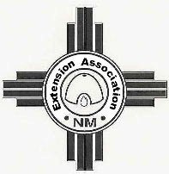
MARY MOORE MEMORIAL SCHOLARSHIP APPLICATION
For 4-H Member Attending New Mexico State University
Sponsored by the Extension Association of New Mexico

Applicant’s Name:
Mailing:
Address:
City, State, Zip Code:
Phone Number: Home Cell
E-mail Address:
Date of Birth:
Parent/guardian name:
Parent/guardian address if different from yours:
City, State, Zip Code:
Phone Number: Home Cell
E-mail Address:
Applicant’s signature & date:
County Agent’s signature & date:
Use separate pages to answer all the following questions.
- List the 4-H clubs and county in which you were active and how many years in each.

- List your participation in 4-H projects and include years. With each project listed include your participation in demonstrations, talks, exhibits, tours, workshops, camps, contests/judging events, awards received or other related experiences in 4-H projects

- List the leadership roles you have held in 4-H, school, church, clubs, and community organizations.

- List community service projects you have worked on. Describe any citizenship programs or activities you have participated in.

- College attending or planning to attend and anticipated major.

- County Agent or 4-H leader’s name, address, and phone number for verification or 4-H participation

Application and four copies must be sent to State Scholarship Chair by March 1. Attach an application page to all copies. Last name should appear on the top of each page of application.

Send To: Rosalie Lopez
HC 80 Box 256A Las Vegas, NM 87701
505 429-6420 showmerosa@yahoo.com Revised January 10, 2020

