**Department of Extension Family and Consumer Sciences**

**Quarterly Newsletter**

**June 2013**

* **Facts: The Affordable Care Act**
* **Power Companies Issue Mylar Balloon Alert**
* **MERS-CoV: Should You Be Concerned?**
* **Staying Hydrated During Summer**
* **Lesser Known Complications of Diabetes, Part 2**
* **Your Food Label Speaks!**
* **Notary Public = *Notario Publico*?**



**Facts: The Affordable Care Act**

Sonja Koukel, PhD  
Community & Environmental Health Specialist

The Patient Protection and Affordable Care Act (PPACA) commonly called Obamacare or the Affordable Care Act (ACA) is a U. S. federal statue signed into law by President Obama in March 2010. The aim of the Act is to reduce the rate of health insurance coverage for Americans and reduce the overall costs of health care. Over the past two years, there has been much debate about how well the ACA will help to solve the health care issues in America. Changes at this large scale are messy and most individuals find the law difficult to understand. The good news is that the ACA is already making it easier for people to get, keep and afford health care benefits. It helps protect consumers from discriminatory insurance practices, and it strengthens coverage for people who are on Medicare.

Benefits that are already in effect:

* A number of insurance plans, including Medicare, now cover more preventive services, such as colonoscopies and mammograms, with no out-of-pocket costs to you.
* The law has been gradually closing the Medicare Part D coverage gap, the “doughnut hole.” Savings increase annually until the gap is closed in 2020.
* Insurers can’t drop your coverage even if you become sick or disabled.
* Adult children can stay on their parents’ health insurance up to age 26.
* Plans can’t limit how much they pay for your lifetime medical costs. Beginning January 2014, the law also prohibits annual limits on the dollar amount of coverage for an individual.
* Plans can’t deny coverage for children under age 19 who have pre-existing conditions. The provision extends to people of all ages in 2014.
* Health insurance marketplaces, often called exchanges, will open in every state, making it easier for people without insurance, small businesses and self-employed workers to buy private insurance. Coverage begins in January 2014, but by October 2013, any American can compare plans and buy health insurance online.

Want more basic information? Kaiser’s Health Reform Source offers a delightfully informative and engaging animated video available on YouTube. Follow this link to view the video <http://www.youtube.com/watch?v=3-Ilc5xK2_E>

Or, conduct a Search using all or part of the video title, *Health* *Reform Explained Video: Health Reform Hits Main Street.*

The website [HealthCare.gov](http://www.healthcare.gov) is the go-to place for updated information. Here, you can subscribe to get updates through email or text message. For updates specific to New Mexico, use the *Health Care Law & You* tab on the HealthCare.gov homepage to access an interactive map. Just click on the state to learn more about health care where you live.

(Revised from an original article by Robert Romasco that appeared in the AARP *The Magazine* (April/May 2013).

**Power Companies Issue Mylar Balloon Alert**

Sonja Koukel, PhD  
Community & Environmental Health Specialist

Metallic balloons are popular decorations and gifts, but they play havoc with power lines. Each year, metallic or Mylar balloons cause power disruptions that impact thousands of homes and businesses.

Mylar balloons are made of metallic material that can cause a short circuit and can eventually lead to equipment failure when they come into contact with power lines. Just one balloon can cause a short circuit which can trigger an explosion or melt an electrical wire – potentially resulting in power outages, fires and possible injuries.

To reduce the risk of outages caused by Mylar balloons, power companies suggest:

* Keep metallic and all other types of balloons indoors and away from overhead power lines. Even non-metallic balloons can become entangled in lines and cause an outage.
* Always attach a weight to metallic balloons. Keep them tethered at all times.
* Never use balloons, kites, model airplanes and other toys near overhead power lines.
* Always deflate metallic balloons and dispose of them properly when no longer in use.
* Never release large/oversized latex balloons or large bunches of latex balloons. They can strike power lines when released or when they fall back to the ground.
* **Always assume power lines are energized**. Always keep yourself, your equipment and all other items, including toys, at least 10 feet away from power lines. NEVER assume that a power line is safe to touch. Stay Away! Stay Safe!

Source: El Paso Electric *Connections,* May 2013 (Vol. 24, No. 5)

**MERS-CoV: Should You Be Concerned?**

Sonja Koukel, PhD  
Community & Environmental Health Specialist

The MERS situation is very fluid with new information being shared daily. The information on this page is appropriate to the date published – June 7, 2013. For updated information follow the Resources listed at the end of this article.

**May 29, 2013 – The World Health Organization warned MERS is a great threat and could be the next pandemic as the virus is spreading faster than information is being gained. The source of the virus and mode of transmission remain unknown. At this time, there are no reports of anyone in the U.S. getting infected and sick with MERS-CoV.**

Middle East respiratory syndrome coronavirus (MERS-CoV) has been in the news for several months with sporadic cases reported in the Middle East.  In recent weeks, there has been an increase in cases in Saudi Arabia and cases reported in Britain, France and Italy – among other countries.   At the date of this publication, the World Health Organization has verified 55 cases and 31 deaths.  This new virus is like the severe acute respiratory syndrome (SARS) virus that caused an outbreak in China in 2003.  Of utmost concern, there appears to be human-to-human transmission of the virus with cluster cases seen in health facilities in Saudi Arabia.

**What is a Coronavirus?**

Coronaviruses (CoV) are common viruses. The common cold is a coronavirus that affects most people at some time during their lives. Human coronaviruses usually cause mild to moderate upper-respiratory tract illnesses of short duration. Symptoms may include runny nose, cough, sore throat, and fever. Lower respiratory tract infections tend to occur in people with underlying medical conditions. Fall and winter are typical times of the year for infections to occur.

**Do Coronaviruses Infect Animals?**  
Yes. Most of these coronaviruses usually infect only one animal species or, at most, a small number of closely related species. Research has suggested the new coronavirus is of bat origin, as was the SARS 2003 virus. Researchers *speculate* bat guano used as fertilizer may be the source of the virus. It is the human contact with this source that is allowing for the adaptation of the virus to infect humans.

**How Does the Novel Coronavirus Differ from Common CoV?**  
This coronavirus is different from any other coronaviruses that have been found in people before. As such, this is a *novel* coronavirus. Symptoms of novel coronavirus infection have included fever, cough, and shortness of breath. At this time, the novel coronavirus appears to have a mortality rate greater than 50%. However, this may not be the actual mortality rate as there may be more people infected who recovered without seeking medical treatment. In this situation, they would not be recorded as part of the official case count. In May 2013, the novel coronavirus was given the name MERS-CoV.

**Has there been Human-to-Human Transmission of MERS-CoV?**  
Upon investigating cluster cases of MERS, the World Health Organization suggested the new virus is transmissible human-to-human upon prolonged contact with an infected individual. A study released in May 2013 reported the incubation time for the virus (time from infection to development of symptoms) may be 9-12 days rather than 2-9 days as previously thought.

**What is the Treatment for MERS-CoV?**  
There is no treatment for the virus.

**How Can You Protect Yourself from MERS-CoV?**To date there have been no infections of the MERS-CoV in the United States. If you are traveling to the Arabian Peninsula there are precautions you can take. Also, know that U.S. hospitals and clinics are on alert for patients with symptoms of MERS especially if they have traveled to the Middle East.

* Wash your hands often with soap and water. If soap and water are not available use an alcohol-based hand sanitizer (at least 60% alcohol).
* Avoid touching your eyes, nose, and mouth. Germs are spread this way.
* Avoid close contact with sick people.
* Be sure you are up-to-date with all of your shots. Visit the Centers for Disease Control Travelers’ Health website for more information.
* If you are sick, cover your mouth with a tissue when you cough or sneeze. Toss the tissue in the trash. Avoid contact with other people to keep from infecting them.

Resources:

Download a Free printable eXtension MERS-CoV Topic Paper [www.extension.org](http://www.extension.org)

Centers for Disease Control and Prevention [www.cdc.gov](http://www.cdc.gov)

**Staying Hydrated During Summer**



Carol W. Turner, PhD

Food & Nutrition Specialist

Summer is here, and New Mexico’s temperatures stay high during the longer days of the season. Since you may spend more time outside working and playing during the summer, it’s important to stay well hydrated on those hot days.

Water makes up more than half of your body weight. Every cell, tissue and organ in your body needs water to function properly. Your body uses water to regulate temperature, remove waste and lubricate joints.

You lose water all day. Water is lost when you go to the bathroom, breathe and sweat. Your body cools off by sweating. You lose water faster when the weather is hot, during exercise or when you have a fever. Vomiting and diarrhea can cause you to lose fluid quickly, as well. If you don’t replace the fluids you lose, you could become dehydrated.

**How Much Water Should We Drink Every Day?**

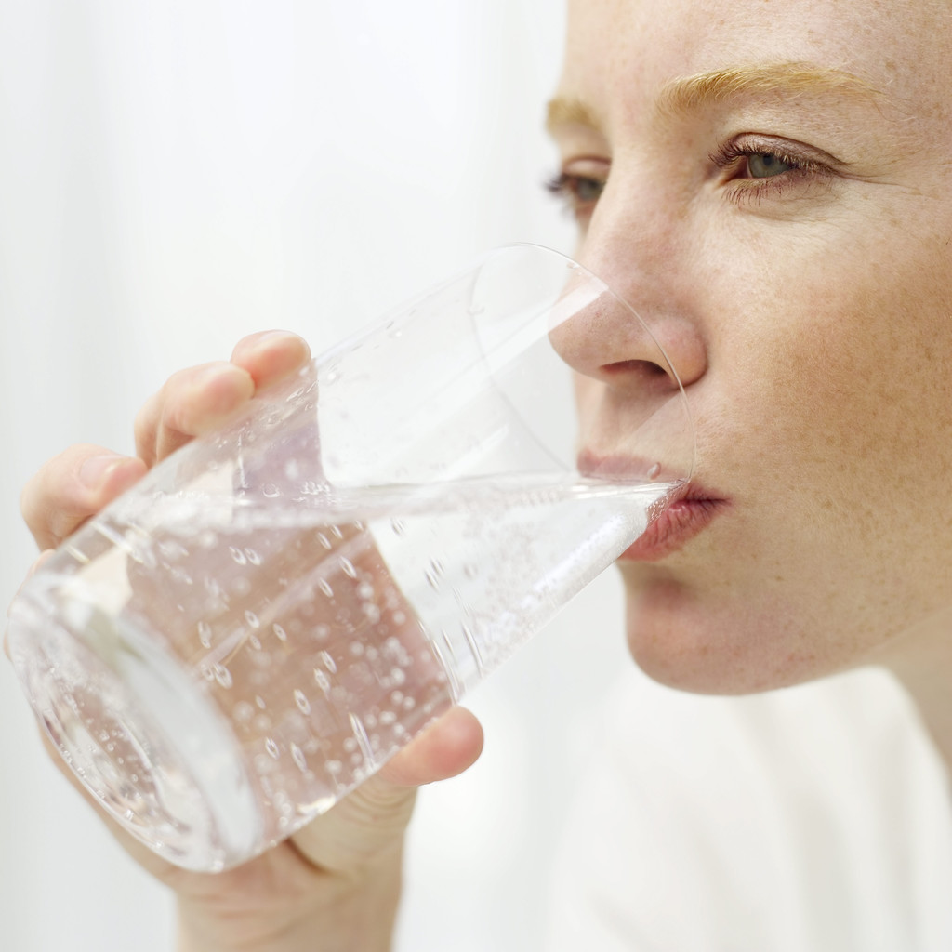

The general recommendation is to drink six to eight 8-ounce glasses of beverages each

day. This means not just include water but other beverages, as well. Different people

need different amounts of water to stay hydrated. Most healthy people can stay well

hydrated by drinking less fluid during the day, particularly if they have soup or fruits

and vegetables that consist of mainly water, such as melons. For some, fewer than eight

glasses of water may be enough. Others may need more than eight glasses a day, however.

Some people are at higher risk of dehydration, including those who exercise a lot, have certain medical conditions or are sick – or those who may not be able to get enough fluids during the day. Older adults also are at higher risk. As you age, your brain cannot sense dehydration like it did when you were younger, so you won’t know when you are thirsty.

**Symptoms of Dehydration Include:**

* Little or no urine output – or urine that is darker than usual
* Dry mouth
* Fatigue or sleepiness
* Extreme thirst
* Headache
* Confusion
* Dizziness or lightheadedness
* No tears when crying

**What Should You Drink to Stay Hydrated?**

Water is the best option for staying hydrated. Drinks like fruit and vegetable juices, milk and herbal teas can add to the amount of water you should drink each day. Fruits and vegetables, such as watermelon, tomatoes and citrus fruits contain lots of water and can contribute to your fluid needs. Soup broths add to your daily fluid intake, as well.

Caffeinated drinks, such as coffee, tea and soda count toward your fluid intake, too, but keep in mind it’s best to limit these since caffeine may cause some people to urinate more often or feel anxious. A moderate amount of caffeine, 200 to 300 milligrams (the amount found in two to four 8-ounce cups of coffee) is not harmful for most people. In addition, remember beverages that contain added sugar, such as sodas and sweetened tea, may add unwanted calories to your diet.

**Are Sports Drinks a Good Option?**Regarding whether sports drinks are a good option, the answer is that it depends on your circumstances. For most people, water is all you need to stay well hydrated. If you work outdoors or are planning on exercising outdoors or at a high intensity and you sweat a lot, however, sports drinks may be needed to replace electrolytes lost during sweating. But sports drinks contain high levels of sodium (found in salt) and sugar that are not necessarily needed when you are not losing fluids. Some sports drinks contain caffeine. If you use a sports drink that contains caffeine, be careful not to get too much caffeine in your diet.

Sports drinks are **not** the same as energy drinks. Energy drinks usually contain large amounts of caffeine and other stimulants (for example, guarana or taurine) that your body doesn't need. Most of these drinks are also high in sugar. Many experts recommend that kids and teens should not have energy drinks.

**What’s the Fuss about Coconut Water?**

Coconut water is a newer, trendy beverage on the market. It is sometimes called, “Mother Nature’s sports drink.” According to the [Academy of Nutrition and Dietetics](http://www.eatright.org/), coconut water is the thin, filmy liquid inside a young green coconut. Coconut water is often marketed as a sports drink because it contains electrolytes and minerals. When exercising, for 30 to 60 minutes, the best beverage for rehydration is water. Athletes exercising more than 90 minutes need electrolyte replacement post-workout. Coconut water has electrolytes, potassium and sodium, but the amount of sodium found in coconut water is not adequate for rehydration. Unlike sports drinks, coconut water is low in carbohydrates which aid in the absorption of electrolytes.

**Alternatives to Plain Water**

If plain water isn’t for you, try adding a slice of lemon or lime to your drink. You can add other flavors to your water by adding other fruits to a pitcher of water such as strawberries, oranges, cucumbers, apples or any fruit or vegetable that sounds interesting. Always clean your produce with cold running water and a brush when possible as you would with any fresh produce before you eat it. Remove pits, stems, and seeds before adding them to the water. Keep the water and produce mixture in the refrigerator to avoid the growth of bacteria. This makes a tasty, refreshing alternative to plain water or soda.

**Here are Some Easy Ways to Stay Hydrated**

* Keep a bottle of water with you during the day. Consider carrying a reusable water bottle and filling it from the tap rather than purchasing bottled water, which is expensive and creates plastic bottle waste.
* If you’re going to be exercising, make sure you drink water before, during and after your workout.
* Start and end your day with a glass of water.
* When you’re feeling hungry, drink water. The sensation of thirst is often confused with hunger. True hunger will not be satisfied by drinking water. Drinking water may also contribute to a healthy weight loss plan, as some research suggests drinking water will help you feel full.
* Drink on a schedule if you have trouble remembering to drink water. For example, drink water when you wake up; at breakfast, lunch and dinner; and when you go to bed. Or drink a small glass of water at the top of each hour.
* Drink water when you go to a restaurant. Not only does it keep you hydrated, it’s free!

Drinking water helps to keep your body hydrated and is even more important in summer months when the temperatures are higher or when you are actively exercising or doing hard physical labor.

**Lesser Known Complications of Diabetes, Part 2**

Cassandra Vanderpool, MS, RD, LD

Extension Diabetes Coordinator

The last newsletter discussed the relationship between diabetes and hearing loss, periodontal disease, and dementia. This article briefly summarizes the links between diabetes and liver disease, female sexual function, bone health, and cystic fibrosis. It contains suggestions for caring for individuals with these complications.

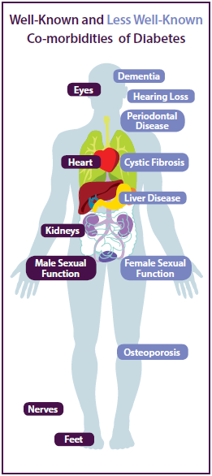

**Liver Disease.** The liver is one of the body’s most important organs in

metabolism. Sometimes, fat accumulates in liver cells. Fatty liver

developed in the absence of alcohol consumption is called Nonalcoholic

Fatty Liver Disease (NAFLD). It can progress to a form of hepatitis,

nonalcoholic steatohepatitis (NASH), and cirrhosis. Cirrhosis results

in the loss of liver function and, in advanced stages, requires a liver

transplant.

Approximately 30% of the general population has NAFLD. People with

diabetes are at increased risk. 44% of those who have type 1 diabetes,

and 50%-70% of those who have type 2 diabetes, have NAFLD. The

development of NAFLD is not fully understood, but it is related to insulin

resistance and oxidative stress.

People with diabetes need to be aware that they may have NAFLD,

even if their liver enzymes are within normal levels. It significantly

increases their risk of cardiovascular disease. They can reduce the risk

of NAFLD by:

* Doing at least 150 minutes of moderate-intensity physical activity

every week.

* Losing at least 7%-10% of body weight.
* Increasing the amount of omega-3 fats eaten and minimizing foods

and drinks high in fructose.

**Female Sexual Function.** About 10%-30% of females who do not have diabetes, and 50% of women with diabetes, experience some form of female sexual dysfunction (FSD). Women who have diabetes experience urinary tract infections, painful intercourse, and vaginal dryness more often. Sexual complications may negatively affect a woman’s diabetes self-care and the emotional support she receives from her partner.

FSD results from psychological, as well as physical, issues. Women who have diabetes and FSD should be assured that their experiences are similar to many women who do not have diabetes. They may benefit from using over-the-counter vaginal lubricants and seeing a gynecologist for evaluation. Recent research supports that women with type 2 diabetes may experience greater sexual satisfaction and less dryness and pain when following the Mediterranean diet. If marital stress is a problem, counseling may also help. A positive, supportive relationship can enhance a woman’s satisfaction and quality of life.

**Bone Health.** People with type 1 diabetes are over six times more likely to have a hip fracture than those without diabetes. Type 1 diabetes is associated with reduced bone mineral density (BMD). Type 2 diabetes is associated with normal or even increased BMD. However, people with either type of diabetes experience a higher incidence of bone fracture than those without diabetes, regardless of BMD. There are many theories for this, but no specific guidelines have been issued for screening for fracture risk in patients with diabetes. Here are some recommendations for people with diabetes:

* Learn about the risk for fractures and osteoporosis.

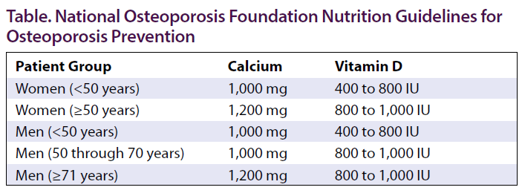

* Follow the guidelines for adequate intake of calcium and vitamin D given in this table by the National Osteoporosis Foundation.
* Maintain adequate blood sugar control. The development of other diabetes complications (e.g., impaired eyesight, decreased balance related to neuropathies, cardiovascular problems) can increase the risk of falls and subsequent fractures.
* Avoid other risk factors for osteoporosis, such as smoking and excessive alcohol intake.
* Follow the general population guidelines for BMD screening:
  + All women older than 65 years should have a DEXA scan to measure BMD.
  + All men older than 70 years should have a DEXA scan to measure BMD.
  + Younger postmenopausal women with higher risk factor profiles should also be evaluated.
  + Men ages 50-69 years with higher risk profiles should also be evaluated.

*Higher risk profiles include smoking, low calcium intake, and inadequate physical activity.

**Cystic Fibrosis.** Approximately 1 in 3,500 children in the United States is born with cystic fibrosis (CF). Over the last 60 years, the life expectancy of people with CF has increased from less than 5 years to over 36 years. Now, almost half the people with CF in the United States are adults. The most common co-morbidity in people with CF is CF-related diabetes. It is because the cells that produce insulin thicken and scar. This type of diabetes is treated very differently than type 1 or 2 diabetes. Recommendations for people with CF who have gestational diabetes or pre-diabetes are also different than they are for the general population.

* The diagnosis of CF-related diabetes does not change the usual CF medical nutrition therapy recommendations. Standard medical nutrition therapy for cardiovascular disease is not recommended. People with CF usually need unrestricted calories, vitamin and mineral supplementation, and a high-sodium diet. Protein should not be restricted if nephropathy occurs.
* Maintain normal blood glucose. Insulin therapy has been shown to be superior to oral glycemic agents in people with CF.
* Women with CF and gestational diabetes may need oral supplements for adequate weight gain, and insulin should match carbohydrate intake instead of seeking to control blood glucose from calorie or carbohydrate restrictions.
* People who have CF and pre-diabetes should spread their carbohydrate intake throughout the day and choose nutrient-dense carbohydrates instead of empty-calorie carbohydrates. Exercise is recommended for overall health, but weight loss should be avoided.

From: Less Well-known Co-morbidities of Diabetes. *On the Cutting Edge*. Winter 2012, Volume 33, Number 6. *On the Cutting Edge* is a peer-reviewed publication by the Diabetes Care and Education dietetic practice group of the Academy of Nutrition and Dietetics.

**Your Food Label Speaks!**

Nancy Flores, PhD

Extension Food Technology Specialist

What does your food product label communicate to the consumer? The product labeling and packaging conveys subtle messages and ideas just like body language! See “happy baby” on jar think “happy baby in your lap”. See “happy dog” white teeth on package, think ”happy dog with fresh breath!” Many food processors use the product label to convey simple facts like net weight of the package, ingredients and nutritional value or health of the food. However, the label is a direct connection with the consumer that the processor can utilize for repeat purchases and to roll out or extend product lines. A label must appeal to the senses of the consumer that will make both a conceptual and a sensual or even an emotional connection with the food product.

Primarily food labels must comply with the Code of Federal Regulation title 21 part 101 [CFR21 (101)] which have been translated by US Food and Drug Administration (US FDA) as *Guidance for Industry: A Food Labeling Guide* (2009). Minimally a food label must provide basic information concerning the content and ingredients of a packaged food product. A food label must have the following information on the principle display panel: statement of identity, net weight in English and metric measurement. The information panel directly to the right of the principle display panel must have the ingredient statement with allergen statement and manufacturing address of the processor or distributor. The format for presenting this basic information on either panel that must not have any intervening material or information. The Nutrition Facts Panel also is included on the information panel. The size of the label depends on the size and shape of the container. For example, a gallon container needs more than a 2-inch label. The character font used must be legible and large enough to read from a reasonable distance by a person with normal vision. Although FDA does not require prior label approval, New Mexico Environment Department (NMED) and United States Department of Agriculture (USDA) regulations require prior approval before labels are printed.

Competing for time and space, consumers looking for quick clues on a food product label that influence their purchase. Although the primary purchasing decision for food or beverages remains taste, price, healthfulness, convenience and sustainability also influence food shopping. Successful new foods feature new or distinctive flavors, recipes highlighting improved/authentic flavor, or a different texture offering homemade quality and a fresher taste/texture. Consumers look for descriptors that convey freshness, homemade flavor and texture as well as authentic ethnic foods. The expiration date is the most used information on the label, followed by the Nutrition Facts Panel, ingredient list front-of-pack nutrition information, icon, or graphic; and the brand name. Many consumers are looking for specific nutritional ingredient or benefits (protein/fiber/minerals/vitamins) and terms that convey an overall balanced approach to health such as “nutritious,” “healthy,” and “better-for-you” are key terms. However terms like “light” or “guiltless” are descriptors that may suggest that something is missing from the food. Consumers want to be ethically responsible buying locally made products described as “farm-raised,” “cage-free,” “grass-fed,” “sustainable,” and “fair trade.” The average supermarket stocks nearly 40,000 items, appealing to a consumer is a daunting task that can be made easier by connecting to the consumer by providing information to make their purchase quick and easy!

References:

US Food and Drug Administration (US FDA; 2009) as *Guidance for Industry: A Food Labeling Guide*

E. Sloan 05-2013 *Label Language: What Matters to Consumers* Food Technology ift.org.

**Notary Public = *Notario Publico*?**

Fahzy Abdul-Rahman, PhD

Family Resource Management Specialist

Some translations, albeit correctly done word for word, may be disastrous. Some marketing to-Spanish translation blunders include American Airlines’ “Fly in Leather”, “Got Milk?”, Parker Pen’s "won't leak in your pocket and embarrass you" logo phrase, “I saw the Pope” t-shirt, and Coors’ “Turn it Loose” slogan.

|  |  |
| --- | --- |
| Image 1[1]. Literally translated to "Fly In Leather", "Vuela Encuero" carries the meaning of "Fly Naked" | Image 2[2]. A businessman in Miami FL promoted Pope John Paul II’s visit to Miami in 1987 with “Vi la papa!” (I saw the potato) t-shirt[3] when it should have been “Vi el Papa!” |

Mistranslation comes in other forms too. The actual concept of Cinco de Mayo got lost in its celebration in the U.S. through misinformed marketers trying to promote goods associated with the celebration and knowledgeable people narrating the facts in an un”sober” state. Myths related to Cinco de Mayo[4] include the day when Mexicans defeated the Spanish, Mexican Independence Day, and the day when the Mexicans gained the ultimate victory over the Europeans – don’t even ask which one!

In personal finance, the most problematic translated English-Spanish term is Notary Public, which when translated word-for-word translates to *Notario Publico*. This is especially problematic because in Mexico, there are individuals who carry the *Notario Publico* title. I have a friend who was once a Notary Public in Las Cruces and when she mentioned that to her Mexican relatives, there were flabbergasted, expressing

“W’aah, *Notario Publico!*”

This was possibly due to the direct word-for-word translation and the high status of a *Notario Publico* in Mexico. A very respected legal figure*,* a *Notario Publico* is trained like a lawyer where one has to pass a grueling law exam and then, obtain residency training under a real Notary. In Mexico City, where the population is of 9 million in 2005, there are only 243 *Notario Publicos*.

In short, compared to a Notary Public in the US, a *Notario Publico* in Mexico is like a magistrate. This is not unique to Mexico. Scotland’s Public Notary is more similar to Mexico’s than U.S.’s. In fact, the U.S.-Mexico difference in Notary Public is quite parallel to that of England-Scotland, where notaries in Mexico and Scotland would get involved in more serious legal matter.

The main differences between a Public Notary in the U.S. and *Notario Publico* in Mexico[5] are as follows:

1. **Responsibilities**: Whereas Public Notaries in the U.S. mainly serve to notify signatures and documents, *Notario Publicos* may be highly involved in real estate transactions, preside over certain legal proceedings for a formation of corporations, provide judicial opinions, check for inconsistencies in legal documents[6], calculate taxes, and collect tax payments.
2. **Qualifications**: A candidate for a NM Notary Public must be a resident of NM, at least 18 years old, able to read and write in English, have clean criminal background, and not have a Notary Public status revoked in the last five years[7]. As previously mentioned, *Notario Publicos* in Mexico are like government-appointed Magistrates with rigorous law training.
3. **Fees**: Most NM Notary Public will notarize signature and document verification for free although some maintain that they have fees. Mexican *Notario Publicos* usually charge from 0.015% to 1.12% of transactions involved, which amount to thousands of dollars for a real estate transaction.

Despite the title similarities, a Public Notary in the U.S. and *Notario Publicos* in Mexico are very different where the one in Mexico serves like a Magistrate in the U.S. Americans buying a house in Mexico may be surprised to learn that a house purchasing contract may be completed with a *Notario Publico*’s service but charged thousands of dollars for his or her service.

1. Flores, H. F. (2010). Traducciones de Slogans que no Sabes si Reír o Llorar. Retrieved May 22, 2013 from http://de10.com.mx/7186.html
2. Rupp, C. (2010). Perdido en la Traducción. Retrieved May 22, 2013 from http://goeastdesign.com/perdido-en-la-traduccion/
3. Pearson, W. & Hattikudur, M. (2011). mental_floss: The Book: The Greatest Lists in the History of Listory. Ney York, NY: Harper Collins.
4. Tures, J. A. (2012, May 5). Common Myths About Cinco de Mayo. Retrieved May 22, 2013 http://news.yahoo.com/common-myths-cinco-mayo-184100388.html
5. Pikoff, J. A. & Crimmins, C. J. (2007). Lost in Translation: Texas Notary Public v. Mexico *Notario Publico*. Retrieved May 22, 2013 from http://www.pikofflaw.com/news.php?id=1
6. E.g. wills, trusts, and company bylaws.
7. New Mexico Secretary of State (2012). Information for Notary Public. Retrieved May 22, 2013 from http://www.sos.state.nm.us/Business_Services/Information_for_Notary_Public.aspx