Department of Extension Family and Consumer Sciences Quarterly Newsletter
September 2013
- ABC’s of ACA: The Basic of the Affordable Care Act (ACA)
- Reach For Correct 100- Calorie Snacks
- Valley Fever on the Rise in New Mexico
- Protect Against Whooping Cough
- What Works to Reduce the Risk of Heart Disease?
- What’s in that Burrito? Labeling Commercial Food Products to Meet Consumer Needs
- Quick Studies

ABCs of ACA:
The Basics of the Affordable Care Act (ACA)
Fahzy Abdul-Rahman
Family Resource Management Specialist

By now, you should have heard about the new health care law as a result of the Affordable Care Act (ACA). Some of its highlighted features are:

- Middle class can afford adequate health insurance;
- Young adults may stay with their parents’ insurance plans until they turn 26 years old;
- Insurance companies need to provide preventive care and annual checkups at no additional cost;
- Elderly receive big discounts on prescriptions;
- People cannot be denied insurance or charged more due to pre-existing conditions;
- Small businesses up to 50 employees receive tax credit for offering health care;
- Companies with fewer than 50 employees won’t face any penalties for not offering coverage to employees;
- Tax credits and cost sharing reductions for middle class families to buy health care insurance

Online marketplace called Exchange where health insurance companies compete to provide health insurance plans;
•
  - No annual or lifetime dollar limit;
- Women cannot be charged more than men for the same health plan; and
- 80% of premiums on actual health care, not bonuses.

The Affordable Care Act is expected to provide health insurance to 32 million of the currently about 50 million uninsured individuals in the U.S. For New Mexico, the comparable numbers are 362,000 of the 417,000 uninsured individuals are expected to be covered by a health insurance plan with this Act’s provisions. These individuals are expected to be covered by one of these means:
  - Medicaid expansion
  - Exchange or Marketplace private health care coverage

People who are insured by Medicare (mostly, 65 years old and older) or employment will continue to be covered by these health plans. The aforementioned Medicaid expansion and Exchange will provide health coverage and additional health insurance financial subsidies to uninsured and underinsured individuals.

Medicaid Expansion

Your eligibility depends on federal poverty level (FPL), determined mainly by number of people in your household and household size, as depicted in Table 1. Individuals in NM who fall below 138%1 FPL qualify for the Medicaid plan, which provides free health coverage. Individuals in NM who are better off by the FPL would obtain financial support in their purchase of health care.
Converting these numbers to annual income, an individual in a NM earning less than $45,000 or living in a household with less than $92,000 may get some assistance in healthcare insurance.

1 ACA provisions expand Medicaid eligibility to 133% FPL. A technical adjustment bumps the rate up to 138% FPL.

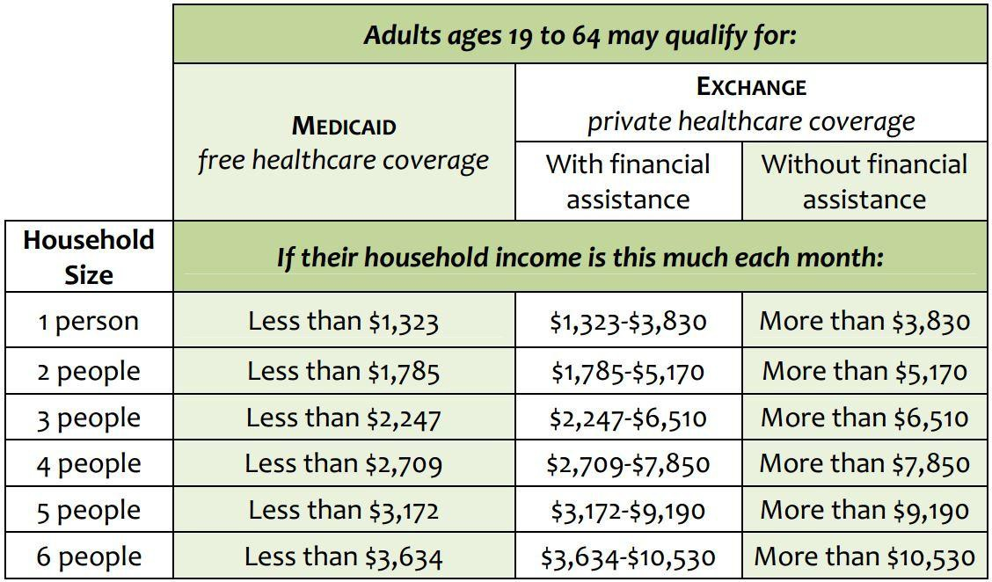
Table 1: Adults’ Eligibility for Medicaid and Exchange Health Insurance
Source: New Mexico Center on Law and Poverty (2013)

Exchange

While Medicaid provides free health coverage to low income households, Conducted via Marketplace, Exchange provides financial assistance for middle-class households. Lower income households who don’t qualify for Medicaid qualify for two federally subsidized affordability provisions:
- Premium Tax Credits: Available to people with income between 100% and 400% FPL. This is for premium payments to keep you in the insurance plans.
- Cost-Sharing Reductions: Available to people with income between 100% and 250% FPL. Cost-sharing determines the out-of-pocket payments such as copayments for doctor’s visit and office visits.

Using the online health insurance marketplace system called Marketplace, people will be able to shop for health care plans as if they were shopping for flights or hotel reservations via Expedia, Hotwire, Travelocity, and Priceline. There will be four types of plans sold in the Exchange: bronze, silver, gold, and platinum – which determine monthly premium and copayments. . The Marketplace website lets you compare different health insurance plans by main characteristics such as premium prices, copay/deductible levels, and covered benefits. Health insurance will still be sold outside Marketplace, but Marketplace is the only pace to get premium tax credits and cost-sharing reductions. These plans will take into account your last year’s or expected Modified Adjusted Gross Income (MAGI).

There are three parties who will utilize the Exchange:
- People who do not get health insurance through their job
- People who earn too much money to qualify for Medicaid
- Small businesses with less than 50 employees

Tied to Taxes

The Exchange system will be highly tied to your taxes, which may be inferred by the premium tax credit. When enrolling online, in-person, mail, fax, or over-the-phone, people need to provide their income or last year’s tax return so that projected premium tax credit can be calculated, similar to using W-4 to calculate the expected or correct amount of tax withholding. Make sure you elect to receive the premium tax credit in advance, otherwise, you will have to pay for the health insurance premium with you money upfront and get “reimbursed” with your tax refund, if any. You may have been overpaying or underpaying for your insurance plans. So, the health plan dollar reconciliation will be done when you file for your tax returns.

Where to Enroll

You can apply for Medicaid and Exchange health insurance plans starting on October 1, 2013 for coverage that begins as early as January 1st. However, you need to apply no later than March 31, 2014, otherwise you may be fined for being uninsured. Remember that you can get Medicaid even if your employer offers health insurance benefits. If you are not sure of your Medicaid and Exchange eligibility, just contact one of the listed contact information below. To apply for Medicaid or Exchange, you need to get in touch with at least one of these services:
- New Mexico Human Services Department, Income Support Division (ISD) office: 1-888- 997-2583, www.hsd.state.nm.us/MAD
- New Mexico Health Insurance Exchange: http://www.nmhix.com/
- National Marketplace Toll-Free Call Center: 1-800-318-2596 (TTY 1-855-889-4325)

We project to have other New Mexico assistance services such as walk-In Service Centers, in- person “guides” at agencies, and clinics across the state, telephone (to be announced). Their details should be finalized soon.

Reach For Correct 100-Calorie Snacks
Carol W. Turner, Ph.D., RD, LD Food & Nutrition Specialist

The ubiquitous 100-calorie snacks are all the rage. That’s great, because 100 calories is just about the right amount for a between-meal snack. The packages function as portion control so we don’t overeat.

There’s a downside, however, to many of these little prepackaged goodies. Most of these have little to no nutritional value and don’t really provide good fuel for the body. A typical 100-calorie pack usually includes chips,

cookies or crackers. These items are highly refined and don’t come close to resembling “real food.”

Because they are so highly refined, they don’t satisfy like real food would. Instead of satisfying our appetite, they tend to just make us hungry for more. How many times have you eaten one, and then gone back for one or two more?

Snacks are an important part of our daily nutrition intake. They help to bridge the gap between meals and may actually assist with health and weight goals. When it comes to fueling the body and brain, eating every three hours or so can help control blood sugar, help maintain mental focus and concentration, and help keep our metabolic fire burning hot throughout the day. So, snacking is actually a good thing.

But it’s important not to view snack time as “treat time.” Think of it instead as one of your scheduled fuel stops throughout the day, providing a needed boost of nutrition and energy to get you through until the next feeding.

When choosing a snack, consider the ingredients. Look at the Nutrition Facts label and see if the snack contains a lot of sodium (up to 150 mg per serving for a snack food portion is realistic). Does the snack contain fiber (which would help sustain energy levels and blood sugar)? An ideal snack should contain carbohydrate and fiber. Protein may be included as well. Some foods will contain all three; others may need to be combined with one or two other food items.

The size of your snack should be determined by the length of time until the next meal. One hundred calories can sustain you for a couple of hours. If you need for the snack to last three to four hours, 150 to 200 calories might be better.

Consider these healthy 100-calorie snacks that are as delicious and satisfying as they are nutritious:
- One whole banana
- ½ ounce of nuts
- 1 reduced-fat string cheese stick and ½ cup of raw veggies
- 8 ounces of nonfat or low-fat milk
- 3 cups of air-popped popcorn
- 1 tablespoon peanut butter with 4 apple slices
- ¼ whole grain pita pocket with 2 tablespoons hummus
- ¼ cup salsa with 4 to 6 whole grain crackers
- 4 ounces yogurt with ½ cup fresh fruit
- ½ cup high-fiber dry cereal mixed with 1 tablespoon raisins and 1 tablespoon unsalted nuts or seeds
- 1 hard-boiled egg with 4 whole grain crackers
- ½ cup edamame

Valley Fever on the Rise in New Mexico
Sonja Koukel, Ph.D.
Community & Environmental Health Specialist

Nearly 16,500 new cases of Valley Fever were reported in Arizona in 2011. While California reported nearly 4,500 for the same year, New Mexico reported only 75 cases. Health experts consider Valley Fever underreported in NM. (NM Office of Border Health)

What is Valley Fever?
Valley fever is a respiratory infection caused by the inhalation of fungal spores, specifically, coccidiodes (kok-sid-e-OY-deze) organisms. The spores are commonly found in the desert soils throughout the U.S.-Mexico Border Region, including NM, and are dispersed
during moderate and high wind events. Anything that disrupts the soil, such as farming and construction can stir the spores into the air. When the
fungi are breathed into the lungs valley fever or acute coccidioidomycosis (kok-sid-e-oy-doh-my-KOH-sis) can occur.

What are the Symptoms of Valley Fever?
Valley fever is the initial form of coccidioidomycosis infection. The majority of individuals who contract the disease suffer mild to moderate respiratory distress similar to allergies or flu-like symptom. Because of these similarities the disease is often misdiagnosed and/or mistreated as pneumonia, influenza (flu), tuberculosis, chronic bronchitis and asthma.

When signs and symptoms do occur, they appear one to three weeks after exposure. Symptoms may include:
  - Fever
  - Cough
  - Chest pain – these may vary from a mild feeling of constriction to intense pressure like that of a heart attack
  - Chills
  - Night sweats
  - Headache
  - Tiredness
  - Joint aches
  - Red, spotty rash

The rash that sometimes accompanies valley fever is made up of painful red bumps that may later turn brown. The rash mainly appears on the lower legs, but sometimes on the chest, arms and back. Sometimes the rash may appear as a raised red rash with blisters that look like pimples.

Who is at Risk from Valley Fever?

Anyone who inhales the spores that cause valley fever is at risk of infection. Some experts estimate that up to half the people living in areas where valley fever is common have been infected. People who have jobs that expose them to dust are most at risk — construction, road and agricultural workers, ranchers, archeologists, and military personnel on field exercises.
Also at increased risk are people with weakened immune systems and older adults.

How severe is Valley Fever?
For most infected individuals, valley fever often clears on its own. However for the 1-3% of all who contract the disease, the infection spreads beyond the lungs to other parts of the body. This is a more serious form of the disease and can cause chronic pain, skin rashes, bone deformations, encephalitis (swelling of the brain), and tumors.

When Should I See a Doctor?
Make an appointment with your doctor if you develop signs or symptoms of valley fever. Valley fever is under reported and not a disease doctors are likely to look for and diagnose. Do not hesitate to ask questions during your appointment.
  - Do I have valley fever?
  - Are there any other possible causes for my symptoms?
  - What kinds of tests do I need?
  - What treatment approach is recommended, if any?
  - Should I schedule a follow-up appointment to make sure I’m recovering as expected?
  - How long does a full recovery take?

What is the Treatment for Valley Fever?
Most people with acute valley fever don't require treatment. Even when symptoms are severe the best therapy for, otherwise healthy, adults is often bed rest and fluids — the same approach used for colds and the flu. Still, doctors carefully monitor people with valley fever.

If symptoms don't improve, become worse, or if you are at increased risk of complications, your doctor may prescribe an antifungal medication. All antifungals can have serious side effects.
However, these side effects usually go away once the medication is stopped. The most common side effects are nausea, vomiting, abdominal pain and diarrhea.

Prevention
In New Mexico and other border states, valley fever is common. Precautions should be taken especially during the summer months when the chance of infection is highest.
  - Wear a mask when outdoors.
  - Stay inside during dust storms.
  - Wet the soil before digging to keep the dust at a minimum.
  - Keep doors and windows tightly closed.

Resources: www.nmborderhealth.org
www.mayoclinic.com/health/valleyfever/DS00695/DSECTION=complications

Protect Against Whooping Cough
Sonja Koukel, Ph.D.
Community & Environmental Health Specialist

Whooping cough, or pertussis, is on the rise in New Mexico. Anyone can get whooping cough and increases in the disease are occurring in all age groups. But babies who fall ill with whooping cough are the group at greatest risk of complications, including pneumonia, seizures, brain damage and death. (NM DOH 2013)

What is Whooping Cough?
Whooping cough is an infectious disease caused by the bacterium Bordetella pertussis. It is a disease of the nose and throat that causes fits of coughing. For some, the coughing makes it hard to breathe. Young infants are the most vulnerable to severe disease and possible complications. Many are hospitalized every year and some have died.

What are the Symptoms of Whooping Cough?
Symptoms usually appear 4 to 21 days after exposure to someone who has the illness. The symptoms of whooping cough usually occur in 3 stages.
  - Stage 1: The first stage begins like a cold, with a runny nose, sneezing, mild fever and cough. The cough may be mild at first but soon gets worse.
  - Stage 2: The second stage includes uncontrolled coughing or coughing spasms that may be followed by a whooping noise when the person breathes in air. During these severe coughing spells, a person may vomit, or their lips or face may
look blue from a lack of oxygen. The infected person may appear well between coughing spells. This stage may last several weeks.
  - Stage 3: The third stage is the last stage where the cough slowly begins to disappear. This stage may also last for several weeks.

It is possible to have whooping cough with only the cough that lasts for 2 weeks or longer. Some infected persons do not experience the coughing spasms, whooping sound, or vomiting.

How is Whooping Cough Spread?
The bacterium that causes the disease is found in the nose and throat of infected people. These bacteria spread through the air in droplets that are produced when an infected person sneezes and/or coughs. Persons in the early stage of illness (Stage 1) are the most contagious.

After 5 days of taking doctor prescribed antibiotics, people are no longer contagious. People who do not take antibiotics are contagious for 21 days after the coughing spasms begin.

What Treatment is Available for Whooping Cough?
Whooping cough is caused by a bacterial infection therefore antibiotics are the prescribed treatment. Antibiotics will shorten the length of time the person is contagious. If antibiotics are

started in the early stage of the disease the illness may be less severe. However, even with the antibiotics, people may cough for many weeks.

How Can I Protect Myself and My Family from Getting Whooping Cough (Pertussis)?
  - Whooping cough can occur at any age, but getting vaccinated lowers the risk. Keep your children up to date on their vaccinations. The pertussis vaccine is given at ages 2, 4, 6, and 12-18 months, at 4-6 years of age when a child begins school, and at 11 years when starting middle school.
  - Adults of all ages, particularly if they are around babies, should receive a booster pertussis vaccination if they have not previously received one.
  - Pregnant women after 20 weeks of gestation should receive a single booster dose of pertussis vaccine if they have not previously had a booster.
  - People who are sick with whooping cough should be kept home until they have been treated with antibiotics for at least 5 days and are well enough to return to school, work or daycare.

Source: NM DOH available at http://nmhealth.org/pertussis

What Works to Reduce the Risk of Heart Disease?
Cassandra Vanderpool, MS, RDN, LD Extension Diabetes Coordinator

People with diabetes are two to four times more likely to develop cardiovascular disease and stroke than those without diabetes. These two conditions account for about 65% of deaths in people with diabetes. Fortunately, cardiovascular disease can be prevented up to 80% of the time through healthy lifestyle habits, including heart- smart eating.

Research published over the last 10-20 years has greatly improved our understanding of the relationship between foods and heart disease. Some recommendations have changed as a result. For example, have you heard that you need to reduce your total dietary fat or cholesterol intake to lower your risk of heart disease? Current data do not support these outdated recommendations. They have minimal, if any, effect on heart disease. Here are the top 10 food approaches to really reduce your risk of heart disease:

- Include plant sterols/stanol esters in your diet. Foods with plant sterols/stanol esters reduce LDL (bad) blood cholesterol by about 14%. Suggestion: Use one tablespoon of a cholesterol-lowering margarine with at least 0.65g of plant sterols or 1.7g stanol esters per serving at lunch and dinner each day.

- Increase soluble fiber. Psyllium and oat bran are very effective in reducing total and LDL blood cholesterol. Suggestion: If you struggle to eat enough high-fiber foods, try a fiber supplement like Metamucil.

- Substitute monounsaturated and polyunsaturated fat for saturated fat. Most people have heard they should reduce saturated fat. Unfortunately, they tend to replace it with carbohydrate, which is ineffective or even harmful in combating heart disease. Replacing saturated fat with monounsaturated or polyunsaturated fat lowers LDL blood cholesterol and decreases the risk of coronary heart disease. Suggestion: Use canola oil in cooking instead of butter or other animal fats.

- Balance omega-3 and omega-6 fatty acids. These both come from polyunsaturated fats, but most Americans eat few omega-3 fatty acids when compared to omega-6 fatty acids (1:25). Omega-3 fatty acids reduce high blood pressure, vascular clotting, triglyceride levels, atherosclerosis, and inflammation. To reduce the risk of heart disease, increase the amount of omega-3 fatty acids in your diet. While canola oil, flaxseed, soybeans, and some nuts and seeds are good plant sources of omega-3 fatty acids, the sources that are most effective in reducing heart disease risk are fatty fish, fish oil, and marine plants. Suggestion: Eat 3 oz. fatty fish (such as mackerel, trout, salmon, tuna) at least twice a week.

- Eat nuts. Eaten in appropriate portions (a serving is one ounce), nuts lower total and LDL cholesterol. Research has shown for over three decades that nuts can reduce the risk of coronary heart disease by up to 40%. Suggestion: Get a one-ounce nut tin to help with portion sizing, and enjoy one tin of nuts daily.

- Eat soy/legumes. Even in small amounts of one to three ounces per day, soy can reduce the risk of heart disease. Suggestion: Add some tofu to your smoothies, or snack on edamame.

- Drink purple grape juice/red wine. The antioxidants in deep purple grapes promote the healthy flow of blood through the vessels. Suggestion: Drink 8 oz. purple 100% grape juice or 4 oz. red wine daily.

- Drink tea. It helps keep the arteries and veins healthy and is associated with lower blood cholesterol levels. Suggestion: Drink one or two cups of tea daily.

- Use garlic. Garlic has many of the same effects as deep purple grapes and also reduces the production of blood cholesterol. Garlic must be chopped, steamed, or crushed to release the compounds that produce these healthy effects. The optimal dose is still being researched, but conservative estimates are one to three cloves per day. Suggestion: Use chopped garlic to season cooked foods.

- Eat chocolate. Cocoa processed with alkali (dutch-processed), high fat chocolate, and high sugar chocolate are not beneficial. However, cocoa without these ingredients is even more beneficial than wine or tea. Suggestion: Add two tablespoons of cocoa powder to a smoothie.

Sources:
New Mexico Department of Health. Indicator Report – Diabetes Deaths. Available from http://ibis.health.state.nm.us/indicator/view/DiabDeath.Year.NM_US.html.

Painter, J. Top 10 Foods that Reduce the Risk of Heart Disease. American Association of Diabetes Educators Webinar. September 29, 2011.

What’s in that burrito? Labeling commercial food products to meet consumer needs
Nancy Flores, Ph.D. Extension Food Technology Specialist

Labeling a commercial food product can be complicated and following all the rules and regulations for each agency can be a challenge. Basically a food label is a legal document between the food producer or processor and the final consumer. The must haves on a food label is what is it, how much does it weigh, who made it and where, and what is in the food. Additional information that may be critical to some consumers is the presence of allergens.
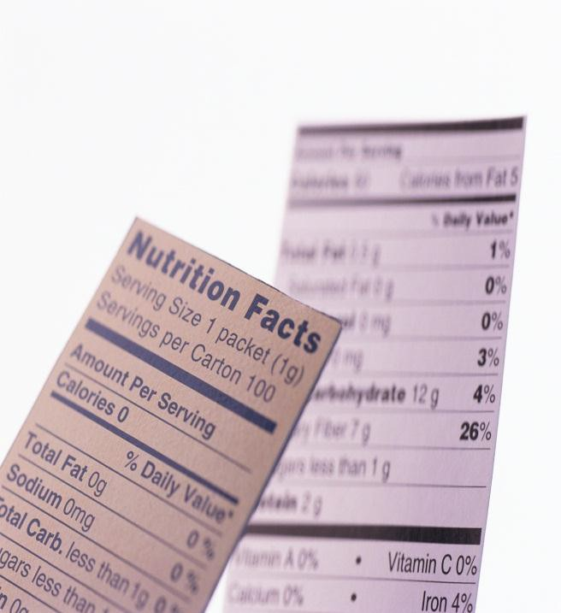Small processors with less than 100 employees selling less than 100,000 units annually are exempt only from nutritional panel if no health claims are made. A label is also an opportunity for a processor to tell a consumer about the product, company and family story that will also give the consumer an emotional connection to the product that will hopefully result in repeat purchases. Think about children who want the cereal box not the cereal!

Packaging and labeling issues should be thought out early in product development, because how the product will be sold—refrigerated or shelf stable— impacts the type of packaging container. The size of the label depends on the size and shape of the container. A gallon container needs more than a 2- inch label. The character font used must be legible
and large enough to read from a reasonable distance. The U.S. Food and Drug Administration (FDA) has requirements for the format or layout of the label for specific content as specified in Federal Code of Regulations (21CFR 101.1-101.9). Although FDA does not require prior label approval, New Mexico Environment Department (NMED) and United States Department of Agriculture (USDA) regulations require prior approval of labels before printing.

Specific labeling information can be found at:
  - Food label: www.cfsan.fda.gov/~dmsflgtoc.html
  - Nutritional food labeling: www.cfsan.fda.gov~dms/nutrguid.html

Allergen statement: http://www.fda.gov/Food/GuidanceRegulation/GuidanceDocumentsRegulatoryInfor mation/Allergens/ucm059116.htm
  - Universal product code (UPC): www.uccouncil.org/

Quick Studies
By Carol W. Turner, PH.D., RD, LD

Soda and Stones
Drinking more fluids is thought to prevent kidney stones. But that may not apply to sugar- sweetened soda. Researchers tracked more than 194,000 people for roughly eight year. Those who drank at least one serving of sugar-sweetened cola a day had a 23 percent higher risk of kidney stones than those who drank less than one serving a week. Likewise, those who drank at least one serving of sugar-sweetened non-cola a day had a 33 percent higher risk than those who drank less than one serving a week.

In contrast, people who drank regular coffee, decaf, or tea at least once a day had a 16 to 26 percent lower risk of kidney stones than people who drank those beverages less than once a week. The risk was 30 to 40 percent lower in people who had at least one serving of red or white wine or beer daily, and 12 percent lower in those who drank orange juice, but not other juices, at least once a day.

What to do: Minimize sugar-sweetened sodas. Researchers suggest that their fructose may raise the risk of kidney stones by making kidney excrete more calcium, oxalate, and uric acid. (Most kidney stones are made of calcium oxalate.)
Clinical Journal of the American Society of Nephrology 2013

Don’t Just Sit There
It’s not just more exercise, but less sitting, that matters. Researchers studied roughly 71,000 women aged 50 to 79 who were asked how many hours a day they spent sitting while at work, in a car, eating, watching TV, etc. After 12 years, those who typically sat for at least 10 hours a day had a higher risk of a heart attack, stroke, or other cardiovascular event than those who sat for fewer hours.

The more exercise the women did, the less likely they were to have a heart attack or stroke. But for a given level of exercise, sitting for at least 10 hours a day still raised the risk, except in the most active women.
What to do: Get out of your chair. One study found that taking a two-minute walk every 20 minutes lowered blood sugar levels in people who were overweight or obese.
Journal of the American College of Cardiologists 2013

