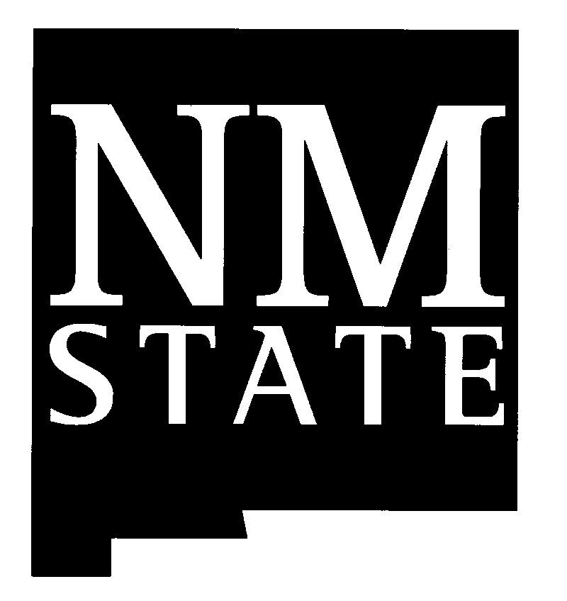New Mexico State University
COOPERATIVE EXTENSION SERVICE
U.S. Department of Agriculture

Year:
Lea County 4-H Report
Name: |  |  |  | Date of Birth:
Age on January 1 of this year: |  | Name of 4-H Leader:
Address: |  | City/Town: |  | Zip Code:
Number of years in 4-H, including this year: |  | Name of 4-H Club or Group:
Number of Members: | Number of meetings held by group: |  | Number you attended:
Club Office held: |  | County Council Office held:
Committees on which you served: Local:
County:

Activities in which you participated:
Explain what you or your group did. For instance, what was your demonstration or talk about, where did you give it, how many people heard you? What kind of tour was it? What did you do at county camp?
Demonstrations/Talks: Example: “How to Measure Baking Ingredients”; Demonstration on how to measure dry and wet baking ingredients. Conducted demonstration during the June Clover Hill 4-H Club meeting at the Extension Office for 10 4-H members.
Judging: Example: Lea County 4-H Wildlife Contest. Participated in District Contest.

Other 4-H Events/Activities: Example: New Mexico 4-H Senior Leadership Retreat. 4-H Apprentice Workshop.
Fair Participation: Example: Exhibited cookies, sewing and crafts in the Yucca Building. Exhibited three pigs at the Lea County Fair.
Leadership Role/Responsibility: Example: Club Reporter, Clover Hill 4-H Club
Citizenship/Community Service Activity: Example: 4-H Canned Food Drive; Collected canned food items and delivered them to the Extension Office. Food items were donated to food bank.
Other Non-4-H Experiences: Example: Student Council Secretary, Clark Middle School

Signatures:
Member
Parent | Leader

__________________________________________________________________________________________
New Mexico State University is an equal opportunity/affirmative action employer and educator. NMSU and the U.S. Department of Agriculture cooperating.

