4-H Favorite Foods Show Study Guide & Handbook
Los Alamos County
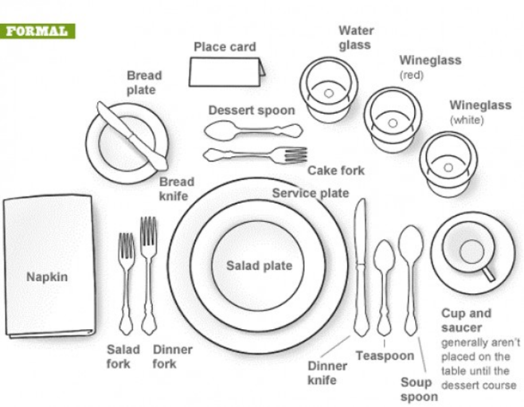
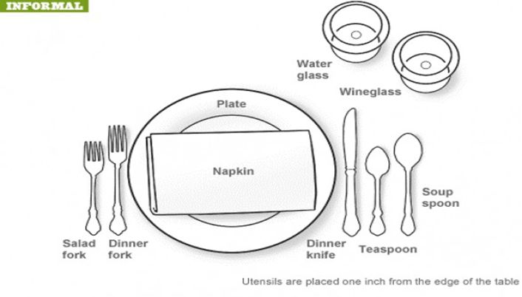

The Favorite Food Show Contest is a fun event that allows members to practice food preparation skills learned through 4-H Food and Nutrition projects, and to exhibit their favorite food as part of a display. By participating in the Favorite Food Show, members will learn how to plan, prepare, and serve an attractive, healthy menu, including:
- The nutritional value of foods, and role of major nutrients in the body.
- How to prepare a recipe, ingredient, and shopping list.
- About food preparation, food safety, and kitchen safety.
- How to set the table.
- Practice public speaking and demonstration skills.

Who can participate? Members, ages 5-18, must be currently enrolled in 4-H. In order to get the most benefit, we strongly recommend that members be enrolled in any one of the Food and Nutrition projects. Cloverbuds may participate at the County Contest level only, but will not be judged. After qualifying at County Contests, Novice and Junior members will advance to District Contests; Senior members will advance to State 4-H Conference.

What Should The Contestant Know?
- Cost of preparation of the Favorite Food (junior and seniors only).
- Nutritional value of the Favorite Food, and function of nutrients in the body.
- History of the Favorite Food.
- Steps in preparation and safe handling of the Favorite Food.
- Purpose of each eating utensil and dish placed on the table setting.

Developed by Roberta O. Rios, Extension Agent-Home Economics. Rio Arriba County Cooperative Extension Service. Revised May, 2006.
Revised by Desaree Jimenez, Extension Agent-Family & Consumer Sciences/4-H. Los Alamos Cooperative Extension Service. March 2016, April 2018, March 2019, February 2020, and March 2023.
Audrey Collins, Admin Asst, Los Alamos Cooperative Extension Service. March 2023.
Table of Contents

Contest Guidelines |  | 3
Planning For A Balanced Diet |  | 5
Nutrients |  | 7
Exercise |  | 7
Planning An Attractive & Appetizing Meal |  | 10
“Getting Started Shopping” Worksheet |  | 11
“How Much Does It Cost?” Worksheet |  | 12
Creating A Menu |  | 13
Rules About Food Safety |  | 15
Table Decorations |  | 17
Table Settings |  | 18
Dining Etiquette (Table Manners) |  | 19
Judging The Favorite Food Show |  | 21
References |  | 22
Poster Stand Pattern |  | 23

Contest Guidelines

- On the day of the contest, preparation facilities, equipment, and preparation time may be limited depending on the location. Keep this in mind when selecting a recipe. It is important to select a recipe that will hold up well throughout the contest. You will prepare and display only your Favorite Food, not the entire menu. Practice preparing your recipe until it can be completed comfortably, and you achieve a good product. You must be able to explain how the Favorite Food is prepared for the judge.

- Select a tested recipe from your 4-H Project Book or a reliable cookbook, magazine, or web site. Chose a recipe that has nutritional value, shows originality and creativity, and is appropriate for your chosen theme. Your Favorite Food must be entered within one of the following categories:
- Nutritious Snack or Beverage | - Main Dish
- Appetizer | - Bread
- Salad | - Sandwich
- Fruit or Vegetable

- Contestants must develop a menu to compliment the Favorite Food and theme choice. Novice and Junior members must prepare a menu for breakfast, lunch, dinner, or snack depending on their Favorite Food. Senior members must prepare a full day’s menu. Include food from all five food groups: the menu should include foods that provide a variety of flavors, colors, textures, and shapes. The choosemyplate.gov website will provide additional information related to food groups, daily nutritional requirements and healthy food and lifestyle choices for individuals.

- Two (2) separate 8” x 11” posters will be made. One poster for the menu listing all foods for the meal (Novice and Junior) or all three meals (Senior). The other for the recipe listing ingredients, amounts (do not abbreviate), number of servings, and food preparation directions. Posters should be freestanding, neat, and with correct spelling. The recipe poster should include the following:
- Cost per serving (Junior and Senior only)
- Menu including Favorite Food

- Each contestant’s display will be set up on a table. Unless otherwise notified, tables will be provided at the contest. Contestants should plan a place setting for one person with the appropriate table covering, dishes, glassware, flatware, and decoration to compliment the favorite food. DO NOT bring fragile china or other expensive items that can be damaged or lost. Provide appropriate serving utensils and a hot mat to protect the table if your dish is hot. The contestant superintendent will provide utensils and plates for the judges.

- The Favorite Food and/or its ingredients MUST be transported to the contest with food safety in mind. Keep hot foods hot and cold foods cold.

- Members must submit an entry form provided by the Agent. See County Contest and State 4-H Conference county deadlines.

- Contestants may not set up the display or prepare their Favorite Food until directed to do so by the superintendent.

- Contestants are responsible for cleaning up their preparation area, display table, and surrounding area after the contest.

Planning For a Balanced Diet

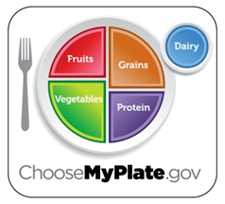
MyPlate focuses on choosing foods from each of the food
groups, maintaining a healthy weight by eating in moderation,
and being physically active every day. You can explore
MyPlate.gov and create your own eating and physical activity
plan.

Food Groups & Recommended Servings
Grains: Eat approximately 6 oz. every day, depending on age and activity level. East at least 3 oz. of whole grains, breads, crackers, rice, or pasta. 1 ounce is 1 slice of bread, ½ cup cooked rice, pasta, or cooked cereal, or 1 cup ready-to-eat cereal.

Vegetables: Eat 2 ½ cups every day. East more dark green veggies like broccoli, spinach, and other dark leafy greens. Eat more orange vegetables like carrots and sweet potatoes. Eat more dry beans and peas like pinto beans, kidney beans, and lentils.

Fruits: Eat 2 cups every day. Eat a variety of fruit. Chose fresh, frozen, canned, or dried fruit. Go easy on fruit juices.

Dairy: For ages 9 and up, get 3 cups or 3 servings every day, and for kids ages 2-8, it’s 2 cups. Go low-fat or fat-free when you choose milk, yogurt, and other milk products. If you don’t or can’t consume milk, choose lactose-free products or other calcium sources such as broccoli, leafy greens, and as fortified foods and beverages.

Protein: Eat 5 ½ ounces every day. Choose low-fat or lean meats and poultry. Bake it, broil it, or grill it. Vary your protein routine – choose more fish, dried beans, peas, nuts, and seeds.

Find your balance between food and physical activity. Be sure to stay within your daily calorie needs (see MyPlate.gov). Be physically active for at least 30 minutes most days of the week. About 60 minutes/day of physical activity may be needed to prevent weight gain. For maintaining weight loss, at least 60-90 minutes/day of physical activity may be required. Children and teenagers should be physically active for 60 minutes every day or most days.

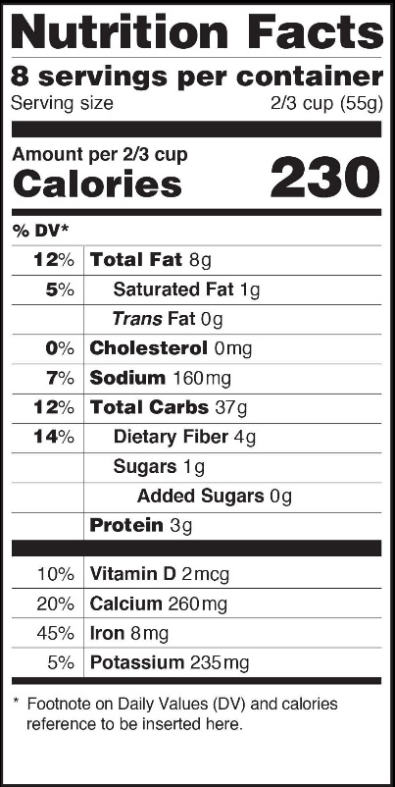

The Nutrition Food Facts Label. The food label provides
accurate information to help make healthful trade-offs
when selecting foods. The label specifies calories, fat,
carbohydrates, fiber, added sugars, and nutrients. A
standard serving size is also given to allow comparisons
between similar products, as well as the servings per
container. If package size allows, it lists the recommended
daily values for fat, sodium, carbohydrates, and fiber for
2000 and 2500 calorie diets. Ingredients are listed from
most to least according to weight. Percentages of vitamin
D, Calcium, Iron, and Potassium recommended for one day
is provided. The label may also make health claims such as
“free”, “low”, “reduced”, or “light”.

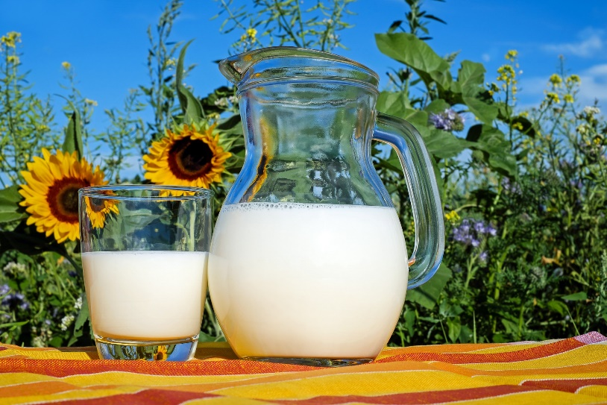
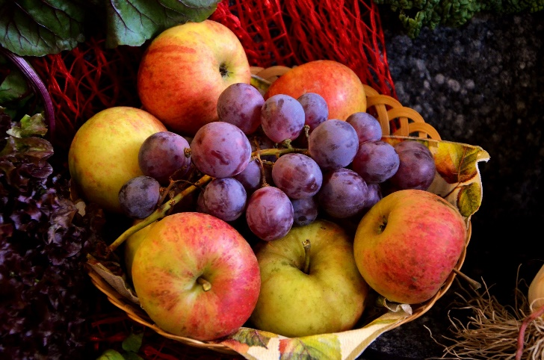
Nutrients

In the Favorite Food Show contest, you will be asked questions about planning, preparation, and nutrients in the food you have prepared. Be prepared by knowing what the main nutrient in your food is and its importance to the body. You should know how it relates to balance, variety, and moderation. There are six major classes of nutrients that we need to stay healthy.

Water Makes up 60-70% of our body weight. It is the largest component of blood,
which carries oxygen throughout the body. Our bodies must maintain a temperature of 98.6F regardless of weather or our activity. When we exercise, we perspire which in turn cools us off. Drink at least eight 8 ounce glasses every day; more if active outdoors.

Protein Builds and repairs all muscles. RNA and DNA are made of protein and are important molecules for transmitting genetic information. Enzymes and hormones are also made of protein. Enzymes help in the digestion of food; hormones help regulate many body functions, like growth. Protein is also a source of calories. Excess protein is either burned for energy or stored in the form of fat.

Carbohydrate Carbohydrates are broken into glucose, which works as the main source of energy for our body. About 60% of our calories should come from carbohydrates. There are two main forms of carbohydrates:
Sugar: honey, fructose, sugar, dextrose, brown sugar, and fruits
Starch: breads, cereals, grains, fruits, and vegetables

Fats Our body can easily make fat from protein and carbohydrates. There is a few compounds which our body cannot make, called essential fatty acids. We must get these from different proteins and carbohydrates.

Vitamins There are two categories of vitamins – fat soluble, which are stored in the body, and water soluble, which are not stored.

Fat Soluble
Vitamin A Helps eyes adjust to dim lights; keeps skin healthy. Keeps lining of mouth, nose, throat, and digestive tract healthy and resistant to infections. Promotes growth. Controls bone growth. Major sources: liver, whole milk, some cheeses, egg yolks, dark green leafy vegetables, yellow fruits and vegetables, fortified foods, butter, and cream.

Vitamin D Helps the body use calcium and phosphorus to build strong bones and teeth, important to growing children, and during pregnancy and lactation. Major sources: fortified milk and sunlight

Vitamin E Helps keep red blood cells intact. Helps keep vitamin A from being lost to oxygen (oxidation). Major sources: soybean, corn, and cottonseed oils.

Vitamin K Necessary for clotting of blood. Major sources: leafy greens like spinach, cabbage, cauliflower, and liver.

Water Soluble
Vitamin C Helps hold cells together and strengthens walls of blood vessels. Helps healing of wounds and building of bones and teeth. Major sources: citrus fruits, tomatoes, strawberries, cantaloupe, cabbage, broccoli, kale, and potatoes.

Thiamin (B1) Helps body cells obtain energy from food; keeps nerves in healthy condition. Promotes good appetite and digestion. Major sources: pork, liver and other organ meats, wheat germ, whole grain or enriched cereals and breads, soybeans, peanuts and other legumes, and milk.

Riboflavin (B2) Aids in utilization of calories. Promotes healthy skin, eyes, and clear vision. Major source: milk, organ meats, and enriched breads and cereals.

Niacin Helps body cells to use oxygen to promote energy; maintain health of skin, tongue, digestive tract, and nervous system. Aids digestion and fosters normal appetite. Major sources: lean meat, fish, poultry, liver, kidney, whole wheat and enriched cereals and breads, peanuts, and mushrooms.

Folic Acid Also called Folate. Prevents birth defects. Helps prevent certain forms of anemia and necessary for formation of blood cells. Major sources: widespread in foods – liver, kidney, yeast, and deep green leafy vegetables are the highest source.

Calcium Assists in clotting of blood, building bones and teeth; promotes proper functioning of nerves, heart, and muscle. Major sources: dairy products, choose low fat options more often, ice cream, leafy green vegetables, canned salmon with bones, and dry beans.

Iron Makes hemoglobin, the red substance in blood, which transports oxygen to and from cells. Major sources: organ meats, oysters, lean meats, eggs, leafy green vegetables, dried peas, and enriched breads and cereals.

Exercise

Exercise is an important part of a healthy lifestyle. Along with a healthy diet, exercise helps keep your muscles, bones, and heart healthy. It is also a great way to reduce stress and control depression. Exercise helps the body to maintain a healthy weight by burning excess calories and fat, which is an important factor in prevention of diabetes, heart disease, and certain cancers. A person should get at least 30 minutes of a combination of aerobic and strength building exercise every day or most days.

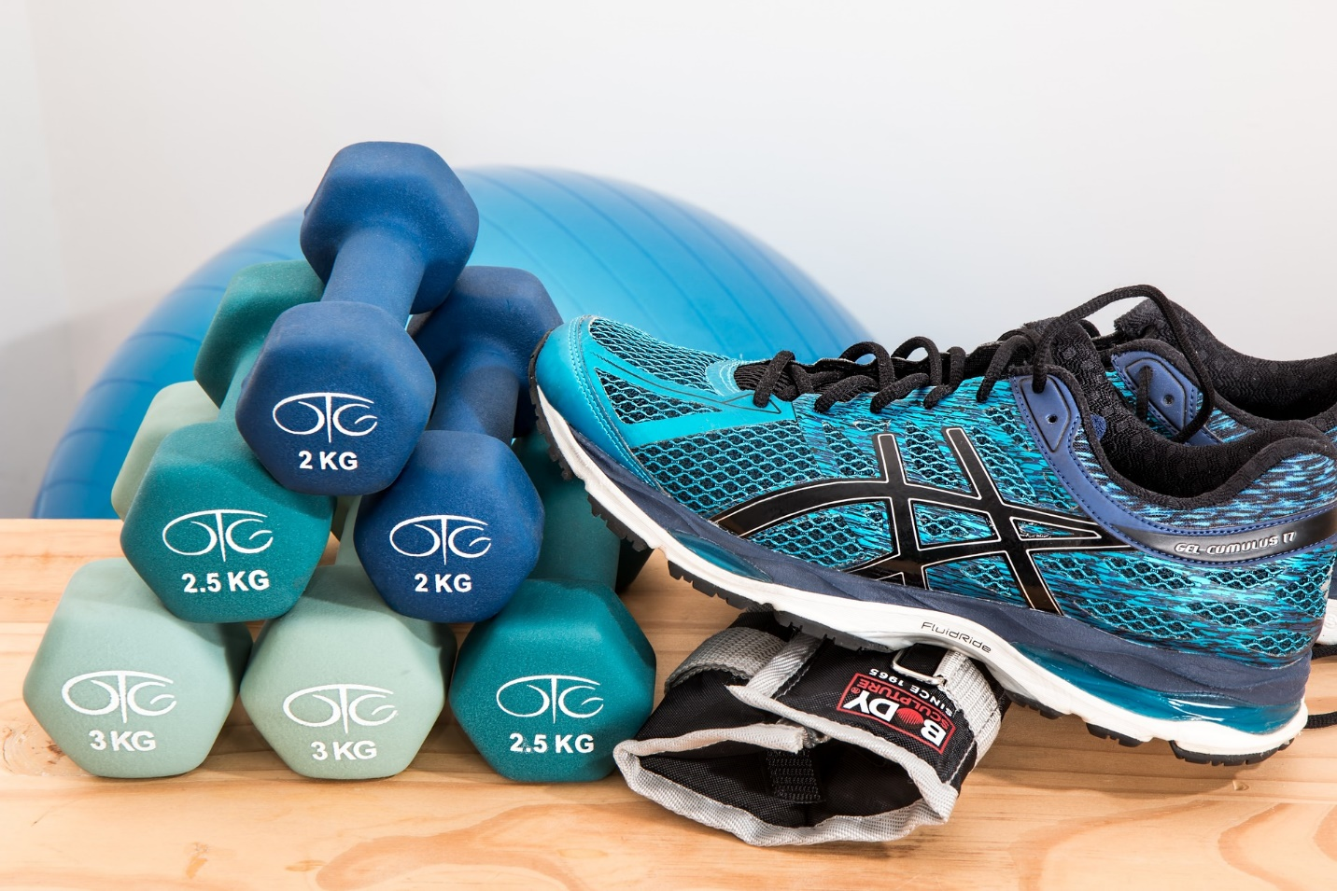
Planning an Attractive & Appetizing Meal
Contrast adds interest to any menu. Here are some tips for creating an appealing meal.

- Texture includes crisp, chewy, hard, and soft foods in the menu.

- Shapes and Sizes. A meal is more appealing when foods of different sizes, shapes, and proportions are combined. Arrange food on the plate interestingly. Mound the potatoes, vegetables, and salads, and place them all well within the rim of the plate.

- Temperature. Serve cold foods cold, hot foods hot. Generally, lukewarm foods have lukewarm appeal. Temperature contrast is important too, regardless of weather. In warm weather, a good menu will include at least on hot food. In cold weather, crisp salads, chilled juices, and ice cream make good contrasts to hot foods.

- Variety is the most interesting when a variety of foods and flavors are offered both within the meal and within the entire day. Avoid repetition.

- Color. Mix colors. Since we “eat with our eyes” the selection of colorful food combinations makes eating a greater pleasure. In arranging foods on the plate, place foods of contrasting color next to each other, when possible.

- Flavor. Combine flavors to build “appetite appeal” as well as “eye appeal” into your meals. Contrast is always good; for bland foods complement foods with tang and zip. Mild flavors are best served first, stronger ones later, with sweets usually thought of as a suitable ending. Enhance flavors in food with spices and herbs, but use wisely and sparingly. Some foods are “made for each other”: pork with apples; lamb with mint jelly; bacon and eggs; peanut butter and jelly; beans and rice, etc. Add, but don’t subtract. Some flavors mask others. For example, meat can be drowned in too much catsup, mustard, pickles, and onions.

- Garnishes add appeal to food, but they should be simple, as well as appropriate in flavor and color. Use carefully. Avoid using artificial food coloring unless it is used to bring out a food’s natural color. In most instances, it is much better to depend on the true color of foods.

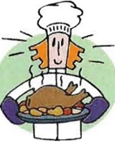
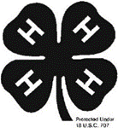
4-H Favorite Food
“Getting Started Shopping Worksheet”

A recipe gives you all the information you need to make your favorite food successfully. Before you start your recipe, you should:
- Read the recipe carefully to fully understand the steps involved in making it.
- Make a list of all ingredients, equipment, and supplies that you need.
- Check to see what ingredients, equipment, and supplies you already have.
- Make your “shopping list”, a list of all ingredients and supplies you need to buy.

What the recipe requires:
- Ingredients | - Equipment | - Supplies

What you have on hand:
- Ingredients | - Equipment | - Supplies

What you need to buy:
- Ingredients | - Equipment | - Supplies

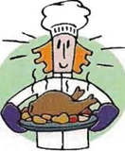
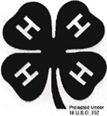
4-H Favorite Food
“How Much Does It Cost” Worksheet

“Cost per Serving” can be calculated by adding the total cost of the recipe and dividing it by the number of servings it makes. By knowing this information you can:
- Compare it to other similar recipes to decide which one is more affordable for your family budget.
- Compare it to the cost of a similar “ready-to-serve” food to decide if it’s more affordable to make it from scratch, or buy it prepared or partially prepared (frozen, mixes, restaurant, etc).

- Use this chart to list each ingredient in your recipe and its cost.

Ingredient | Price | Ingredient | Price

- Cost of recipe

Ingredient Cost

_______________________ ______
_______________________ +______
_______________________ +______
_______________________ +______
_______________________ +______
_______________________ +______
Total =______

- $________ (divided by) ________ = $_________
Total Servings Cost per Serving

Creating a Menu

A menu is a list of the foods being served as part of a meal. Contestants are asked to display an 8” x 11” poster of the menu. Novice and Junior members create a menu, including the favorite Food, for one meal (breakfast, lunch, dinner, or snack). Senior members create a menu for one full day, where the Favorite Food is included in one of the meals. An example of the order in which the foods are listed is:
Appetizer or Soup
Entrée (Main Dish)
Salad
Dessert
Beverage
Following are some additional tips for you to consider when creating your Favorite Food Menu:

- Capitalize the first letter of all words.

- Group menu items as they are going to be served. For example:

French Onion Soup Broiled Sirloin Steak
Sesame Seed Wafers Saltines or Baked Potato Broccoli
Hot Rolls

- When a food item has a special accompaniment( a food that is served with it) you may either place the main food item to the left and the accompaniment to the right:
Chicken Noodle Soup Saltine Crackers
Or write the accompaniments underneath the main food item:
Chicken Noodle Soup
Saltine Crackers

- When a dish is accompanied by two or more items, center the main dish and write the accompaniments to the left and right:
Saltine Crackers Cream of Potato Soup Sesame Seed Wafers
Or write accompaniments underneath the main food item:
Cream of Potato Soup
Saltine Crackers Sesame Seed Wafers

- The beverage is always listed last on the menu.

- Items such as butter, cream, sugar, or salad dressing are not written on the menu unless they are served in a particularly interesting or different way.

- Plan the spacing and arrangement of the food items so that the menu is centered. Allow extra spacing between courses. Below is an example of a 3 course meal:
Tossed Green Salad
Rib Roast
Green Beans Mashed Potatoes
Hot Rolls
Orange Sherbet
Iced Tea
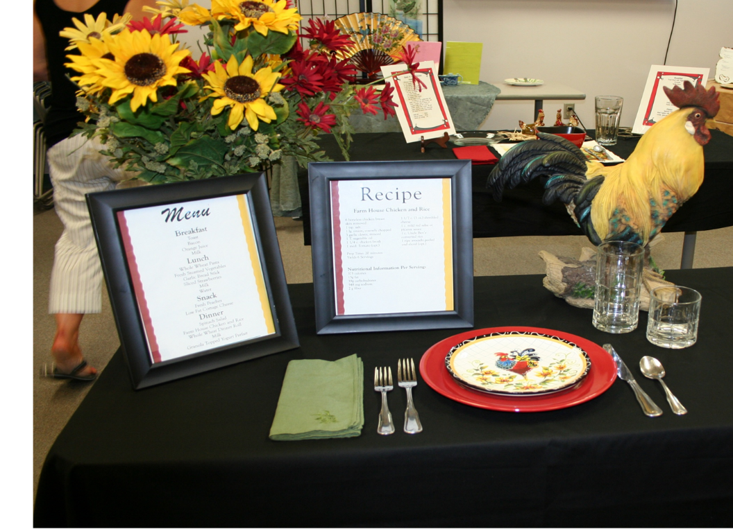
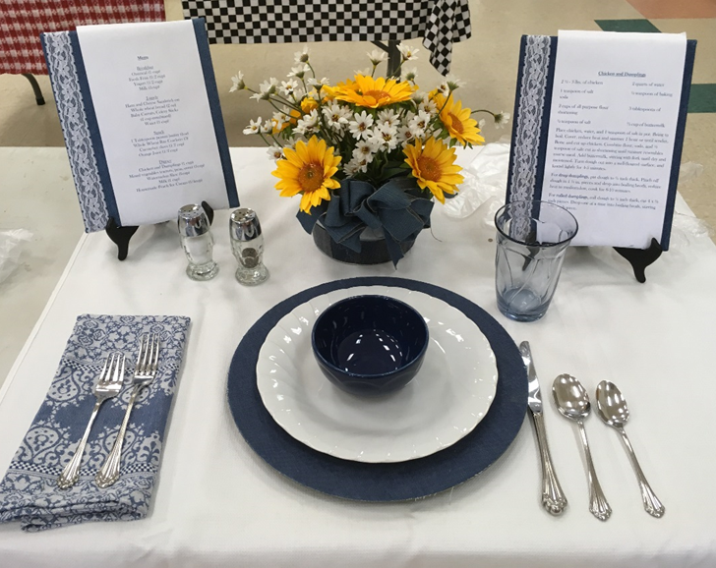
Rules about Food Safety

When You Shop…
- When you’re out and about, make the grocery store your last stop and take food straight home.
- Don’t buy anything you won’t use before the “use by date”.
- Don’t buy food in poor condition. Refrigerated food should be cold to the touch, frozen food should be solidly frozen, and canned food should be free of dents, cracks, or bulges.
- Look for the “Safe Handling Label” on meats and poultry.

When You Store Food…keep it safe, refrigerate
- Maintain the refrigerator temperature between 40F and 33F; the freezer at 0F.
- Freeze fresh meat, poultry, or fish immediately if it won’t be used within two days.
- If refrigerating raw meat, poultry, or fish, put packages on a plate so their juices won’t drip onto other foods. Raw juices can contain bacteria.

When You’re Cooking…cook thoroughly
- Cook red meat until the internal temperature reaches 160F and poultry to 165F. Use a meat thermometer to check for doneness.
- Salmonella, bacteria that causes food poisoning, can grow in fresh, unbroken eggs. Cook eggs until the yolk and white are firm not runny. Do not use recipes calling for raw or partially cooked eggs.

You’re Microwave Cooking…foods cook unevenly
- Cover food so steam can help cook food through.
- Stir and rotate food for even cooking.
- Watch the standing time called for; foods continue to cook during this time.
- Use the oven temperature probe or meat thermometer to check for doneness, inserting it in several places.

When You Serve Food…never leave food out over 2 hours. (And if the temperature is 90F or higher during the summer, cut that time down to 1 hour.)
- Use clean dishes and utensils to serve food. Serve grilled food on a clean plate, not on the one that held raw meat, poultry, or fish.
- Never leave perishable food out of the refrigerator over 2 hours.
- Pack lunches in insulated carriers with a cold pack; never leave lunches out in the sun.
- Serving a large crowd? Serve food from serving containers and refill as needed. Remember: keep hot foods hot, cold foods cold.

When You Handle Leftovers…use small containers for quick cooling
- Divide large amounts of leftovers into small, shallow containers for quick cooling in the refrigerator.
- With poultry or other stuffed meats, remove stuffing and refrigerate separately.
- Bring sauces, soups, and gravy to boil; heat other leftovers thoroughly to 165F.

When In Doubt, Throw It Out…
- Never taste food that looks or smells strange.
- Do not use molded bread or cheese.

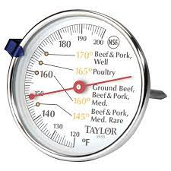

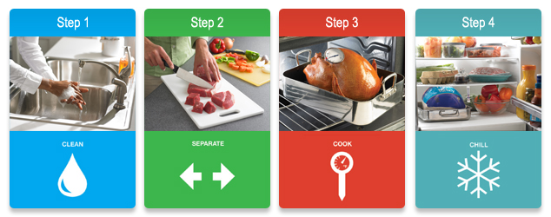

Table Decorations

- You can create a mood with the decorations (centerpiece) and other table appointments. Try to create a theme with the items that you use. The theme can be set around the foods you choose. Example: if you use a wok to cook your food, then you may want to set a table with an Asian theme. Clothing can be coordinated with the overall theme, but costumes should be avoided.

- Simplicity is the key to beauty. Don’t overdo.

- A variety of textures and shapes can be used when making an arrangement.

- Select containers carefully. The container has a lot to do with the effectiveness of the arrangement. Keep the container in proportion to the contents that it holds as well as the area where it is placed. Be sure the container is clean.

- Keep good color coordination in mind. The decoration can help to draw the whole place setting together. You can use your decoration to bring out some color if the rest of your place setting is too dull.

- You may use items other than flowers and candles. Some examples are: fruit, vegetables, pine cones, stuffed toys, etc. Be bold and try something different. Express your personality. Just be sure that whatever you use is not offensive at the eating table.

- Watch the height of the arrangement. Keep the view and conservation zones open. Guests should be able to see the guest near them.

- Candles should never be used without being lit. When lit, candles should not interfere with the view of guests and should be taller or shorter than eye range.

- Keep decorations in proportion to the size of the table. Very simply, don’t use decoration if it is too large or too small.

- A decoration can consist of more than one item. Be careful when combining items to watch the sizes, textures, colors, themes, etc.

- When using flowers for a centerpiece, what for offensive odors, bugs, or any other foreign matter.

Table Settings

Your table setting should follow established standards. Plan your place setting for a card table sized table with a tablecloth and/or place mat. Keep in mind that if only 6’ to 8’ tables are available, two contestants may share ends of tables. The table setting you need depends on your Favorite Food, keeping the following points in mind:

- You need only provide the tableware that will be needed to eat the foods on the menu you have planned.

- If using a place mat, place it so that it is even with the edge of the table.

- The traditional way to place the napkin is with the open corner of the napkin in the lower right hand corner. You may try different ways of placing the napkin, but be prepared to explain the traditional way.

- Place all silverware and tableware one inch from the edge of the table.

- When placing silverware on the table, place as many of each item as needed to eat the meal. The general rule for the guest is to use the silverware from the outside in. In other words, if you have three forks, you will use the one farthest to the left first. The last one to be used would be the one closest to the plate.

- The cutting edge of the knife should always be toward the plate.

- Be sure everything you use to set the table is clean and free of water spots or fingerprints.

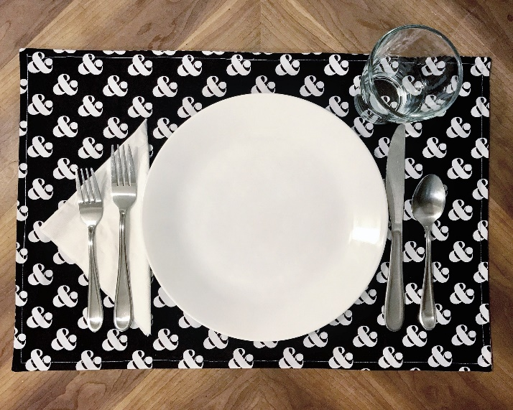

Dining Etiquette (Table Manners)

Introductions
- Younger people are always presented to an older person.
- Gentlemen are always presented to a lady.
- The simplest form of an introduction is just saying the two names: “Jane Smith, I’d like to introduce you to meet my cousin, Fred Jones”.
The Napkin
- As soon as you are seated, put your napkin on your lap.
- When the meal is finished or if you leave the table during the meal, put the napkin on the right side of your plate setting or center if the plates are removed.
Serving
- Receive foods from the left and pass to your right.
Eating
- Wait for the hostess or guest of honor to be served or to start eating or wait until everyone at the table has been served.
- Remove hats off the table.
- Sit straight up on your chair with hands at your lap.
- “Elbows, elbows, if you’re able-keep your elbows off the table!”
- Keep your mouth closed when they chew.
- Don’t slurp the soup; sip it from the side of the spoon.
- Do not leave your spoon in your cup or glass if it used to add a condiment to your beverage, instead put it on the edge of the saucer or plate.
- Do not leave paper sugar packets out; tuck them under the rim of your plate or place on the edge of the saucer or butter plate.
- If food gets caught between your teeth and you can’t remove it with your tongue, excuse yourself from the table and go to a mirror where you can remove it in private.
- You should not leave the table during the meal except in an emergency. If this is the case, simply say, “Excuse me for a moment, I’ll be right back”.
- If you need something that you cannot reach easily, politely ask the person closest to the item to pass it to you.
- “Please pass the salt” – the proper response is to always pick up both the salt and pepper and place them within reach of the person next to you, who will do the same, and so on until they reach the person who asked for them.
- Removing items from your mouth – the general rule is “it should go out the same way it went in”. For example, olive pits can go into the palm of your hand; a piece of chicken bone should be returned to the plate by using a fork. If what has to come out is terrifically ugly, spit it out into a napkin or tissue.
- If food spills off your plate, pick it up with your silverware and place it on your plate.
At End of the Meal
- Do not back your plate when finished. It remains exactly where it is until the person serving removes it.
- Do not announce that you are through with your meal. The fact that your fork or spoon is down shows that you are finished.

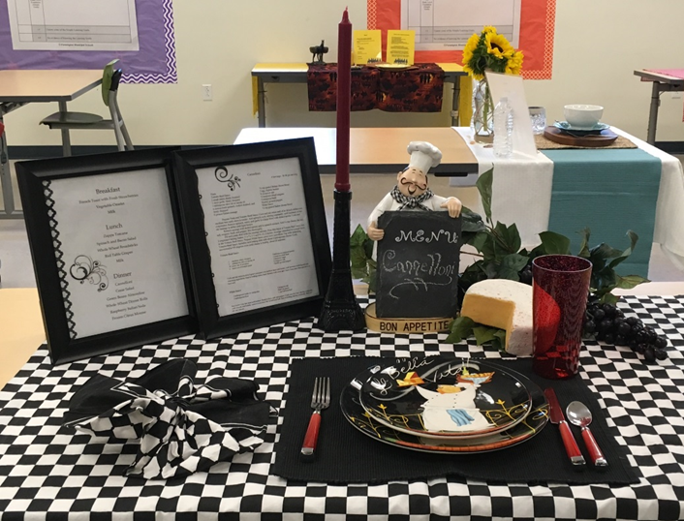
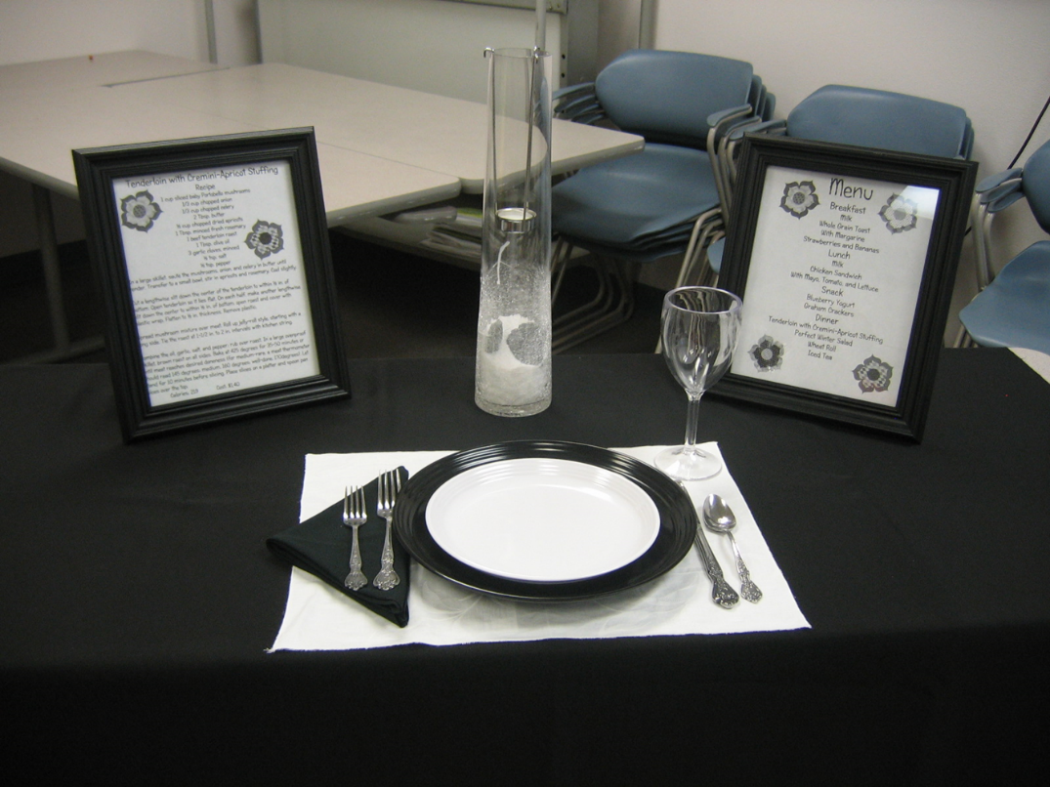
Favorite Food Show Contest Judging

Part of the judging involves being interviewed by a judge. As noted before, the contestant must be able to tell the judge how the recipe is prepared (step-by-step), its nutritional value, cost of the recipe, etc. Following are some examples of questions that a judge may ask:

- How did you prepare your Favorite Food? Did you have any difficulties?
- Why did you choose this recipe for the contest?
- How many times have you prepared your Favorite Food?
- Which food group or groups does your Favorite Food represent?
- Do you know the number of suggested servings per day for these food groups?
- What are the main nutrients in your Favorite Food, and what are their functions?
- What is the cost per serving of your Favorite Food? (Junior and Senior members only).
- What food safety rules did you practice as you prepared, transported, and served your Favorite Food?
- Why did you choose the other foods listed on your menu?
- Why did you choose the centerpiece, dishes, and other items chosen for your display?
- Why is this table setting appropriate for your Favorite food and your menu?

The judge will use a scorecard where points are given for the following categories:

- The Exhibitor – Knows MyPlate; number of servings needed daily from each food group; personal appearance is neat, clean, and dressed appropriately; communicates effectively; knows how the cost per serving is calculated.

- The Favorite Food – Appearance, color, texture, flavor; appropriate temperature for serving; attractively displayed; food safety practiced in handling during preparation and transporting.

- The Menu – Suitable to serve with food exhibited and for the occasion; nutritionally sound with a variety of foods from MyPlate; has variety of color, shape, texture, flavor, and temperature.

- The Display – Posters are correct size, neat, attractive, readable with required information; appropriate for food served; attractive color scheme; appropriate centerpiece; correct placement of dishes, flatware, napkin, etc. for the menu and theme; display area neat around and under the table.

References

“Senior Favorite Food Show Guide”. Joy Best, EHE; Shelly Porter, EHE; Angela Miller, Prg Asst; Barbara Rogers, Pgm Asst; Martha Anderson, 4-H Youth Specialist. NM Cooperative Extension Service. 1997.

“NE/NW 4-H District Handbook”, Favorite Food Show (R2023).

“Plating It Safe”. National Livestock and Meat Board. 444 North Michigan Ave., Chicago, IL 60611.

Foodsafety.gov. March 2016.

MyPlate.gov. March 2019

“A Young Persons Guide To Good Food”, E-112. NMSU Cooperative Extension Service.

“Nutrition Labels”. E-136. NMSU Cooperative Extension Service.

Poster Stand Pattern

Directions: Cut pattern out. Place pattern on cardboard, trace around edges, and cut out. Fold cardboard in half.

