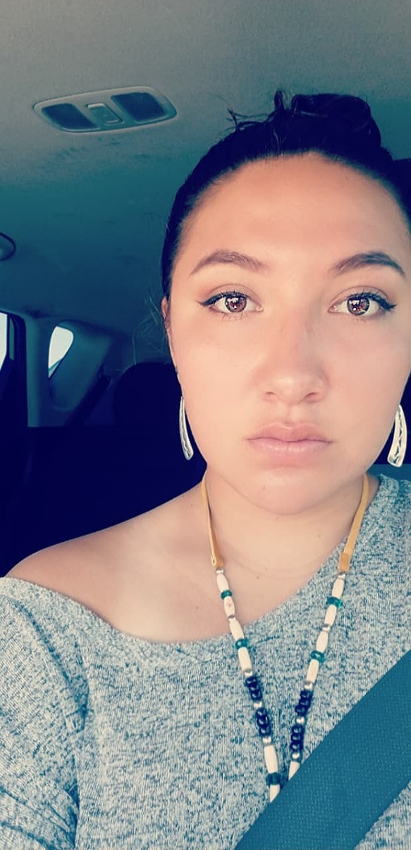

Name: Riley Grace Etcitty

Hometown: Gallup, New Mexico

School: New Mexico State University

Major: Wildlife Ecology and Management

Exp. Graduation Date: Spring 2020

Email: Goo7@nmsu.edu

About Yourself: My name is Riley Etcitty and I’m a 20-year old Navajo Woman. I do not come from an experienced wildlife background, but I find that my passion is working in the outdoors. I love to listen to music, paint, draw, attend concerts, and hike when I can. I regularly volunteer with the clubs I’m apart of at NMSU and attend conferences to help prepare myself for a career in wildlife.

Skills: My skills include experience in Microsoft Word and Excel, comfortable around deceased animals, skilled in the use of simple hand tools/power tools, possess a valid United States Driver’s License, experience with Sherman Traps, ability to operate a manual and automatic transmission, ability to operate an ATV, and weed removal.

Career Experiences: During High school I had a part time job at Hot Topic before I started to attend NMSU. At NMSU I started working at the NMSU- Wildlife Museum under Dr. Jennifer Dry as an undergraduate curatorial assistant in the Spring 2018. I work there to this day. During this past summer I obtained an internship through the Fish, Wildlife, Conservation, and Ecology department’s Joe Skeen award. This summer I worked at the USDA-APHIS- Predator Research Facility in Logan, Utah working with graduate students on coyote research.

Accomplishments/ Clubs/ other: During my time at NMSU I have joined a vast array of clubs such as the American Fishery Society, United Native American Organization, and Southwest Natural Resource Career Trackers. As of Fall 2018 I became President of the NMSU-Wildlife Society Student chapter as well as the Secretary of the American Indian Science and Engineering Society. I have also been awarded an array of Scholarships and 3-time Dean’s List Recipient. Some scholarships include the AIP Scholarship, Bill Humphrey’s, Phillip Church Memorial, Lottery, Chief Manuelito, and New Mexico Distinguished Public Service Award.

Plans after Graduation: My plans after graduating from NMSU include gaining more experience in the wildlife profession and applying to graduate schools. In the long run I aspire to become a wildlife biologist with the Navajo Nation Department of Game and Fish.